

**DEPARTAMENTO DE ELECTRÓNICA, TELECOMUNICAÇÕES E INFORMÁTICA**

**LICENCIATURA EM ENG. DE COMPUTADORES E INFORMÁTICA**

# REDES DE COMUNICAÇÃO I

**LAB GUIDE 01**

**PC ENVIRONMENT (PUTTY, WIRESHARK, GNS3)**

## Objectives

* Set up the PC environment for the lab classes and project execution:

o Putty installation o WireShark Installation o GNS3 Installation

* + Server Preferences
  + Adding Cisco IOS for routers and Ether Switch Router
* Basic network configuration on GNS3 and basic connectivity tests
* Base “Internet” experiments

**Duration**

1 week

## 1. Part A – Setup GNS3, wireshark, putty/Solarwinds

### 1.1. Installation of GNS3

Download GNS3: https://www.gns3.com/

Click on the "Download" link and select the Windows version, Linux or MAC OS according to your system.

During the installation of GNS3 you will be asked if you want to install Wireshark and SolarWinds Putty. It is recommended that you install it.

There is no need to install the GNS3 Virtual Machine and it is recommended that run GNS3 in local server mode.

Linux:

sudo apt update sudo apt install gns3

(Linux) Install from repositories; AUR for Arch/Manjaro distributions and PPA https://launchpad.net/~gns3/+archive/ubuntu/ppa for Debian/Ubuntu based distributions. Install packages gns3-server, gns3-gui, wireshark-qt, and VPCS. Add your user name to the wireshark group (usermod -a -G wireshark USERNAME) and restart.

At (Preferences-General), verify/setup all storing and program paths, avoiding paths with spaces and non ASCII characters.

At (Preferences-Server) enable local server, define 127.0.0.1 as host binding address.

Note: **You do not need an external virtual machine (VM)** to run emulation/simulation software. At (Preferences-GNS3 VM) **disable** the option “Enable the GNS3 VM”.

Open GNS3. Do not open a project. Wait for the server to start.

Go to: Edit ➔ preferences ➔ server

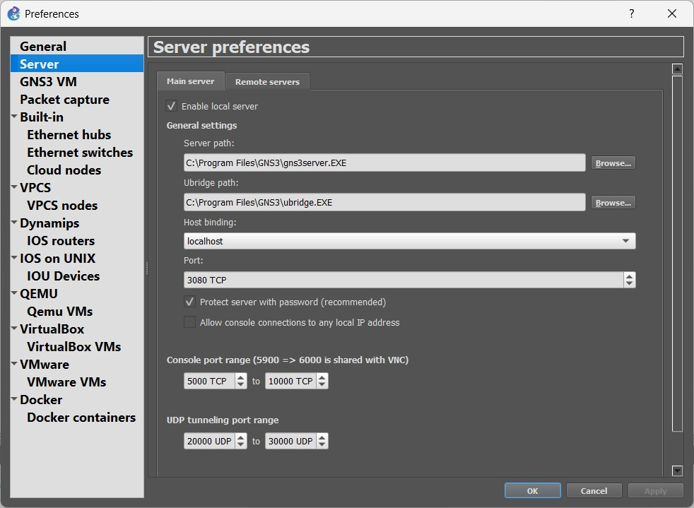

Change UDP tunneling port range from 10000-20000 to **20000 UDP to 30000 UDP**

Close GNS3. Open it again.

Download the following routers’ firmware: (i) Router 7200 Firmware 15.1(4) IOS Image, and (ii) Router 3725 Firmware 12.4(21) IOS Image.

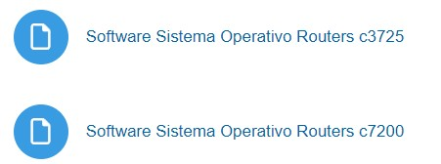

At (Preferences-Dynamips-IOS Routers”) create three new router templates (“New” button on the bottom left):

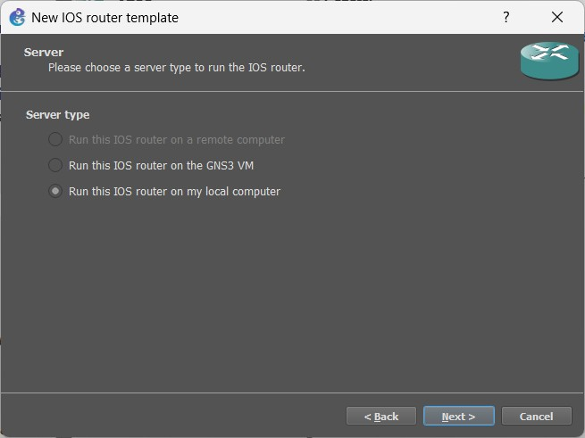

### 1.1.1. Router 7200

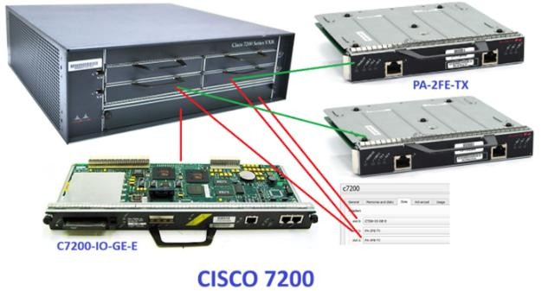

Recommended IOS image: 7200 with IOS 15.1(4) and network adapters:

C7200-IO-GE-E

2x PA-2FE-TX (1 Ethernet →Eth0/0 + 1 GigabitEthernet → GE0/0 + 4 FastEthernet → F1/0,F1/1+F2/0,F2/1)

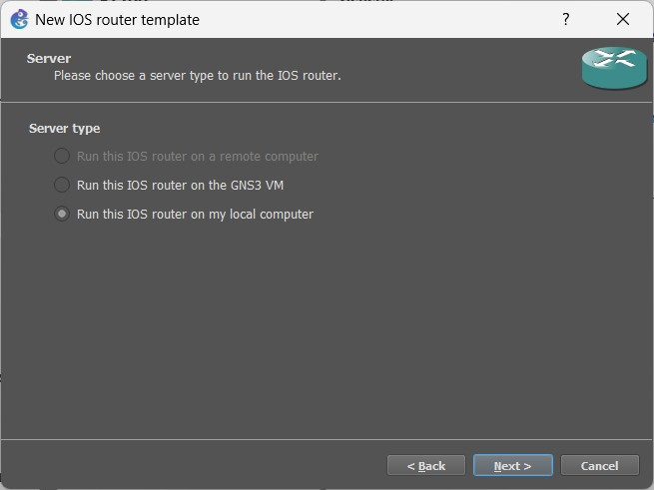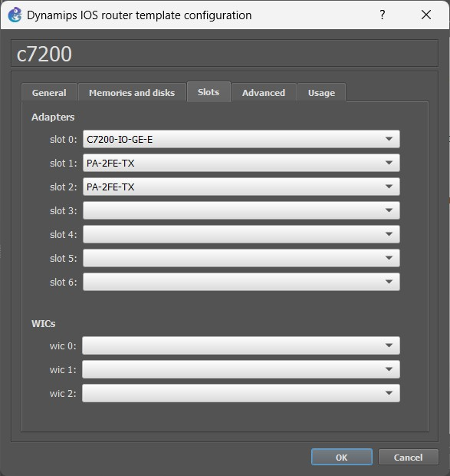

### 1.1.2. ESW Cisco Switch Router (L3 Switch)

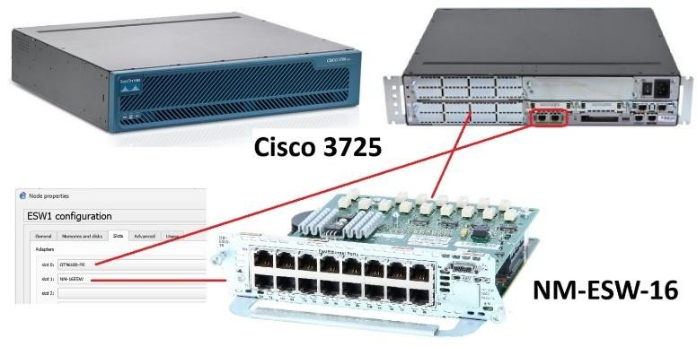

If you still do not have, you must add the ESW to your GNS installation, under Edit ➔ Preferences ➔ Dynamips ➔ IOS Routers ➔ New

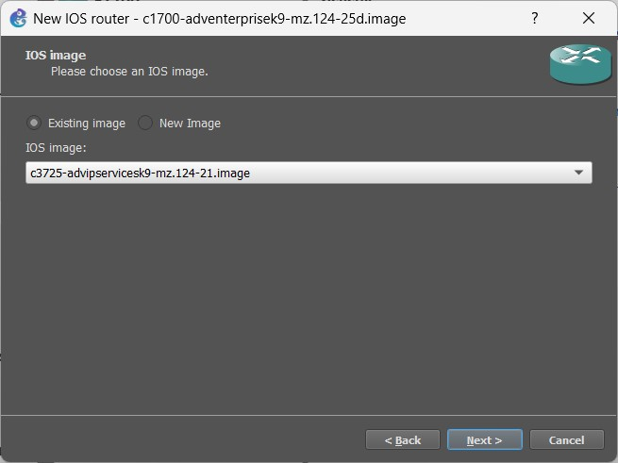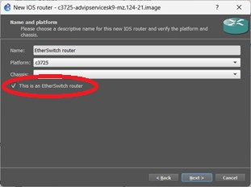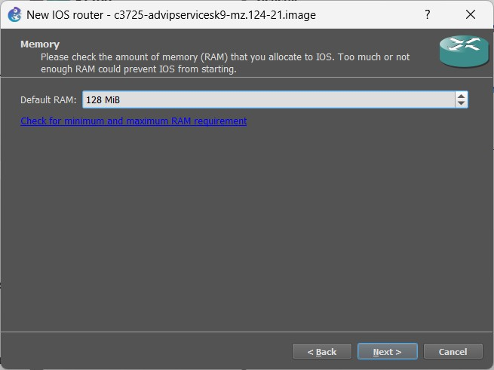

Choose adapters

GT96100-FE

NM-16ESW (2 FastEthernet for routing only → F0/0, F0/1 + 16 port switch module for switching → F1/0 to F1/15 ).

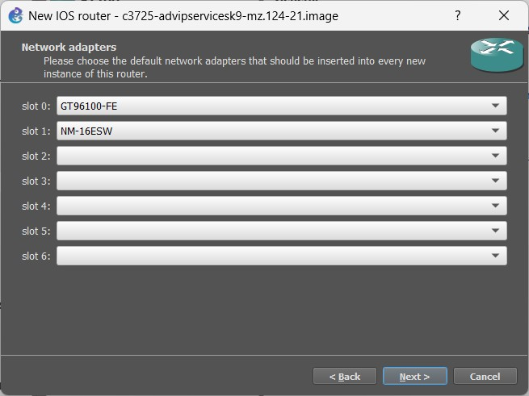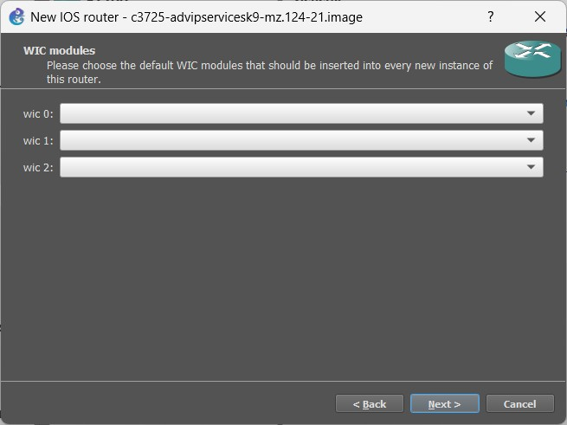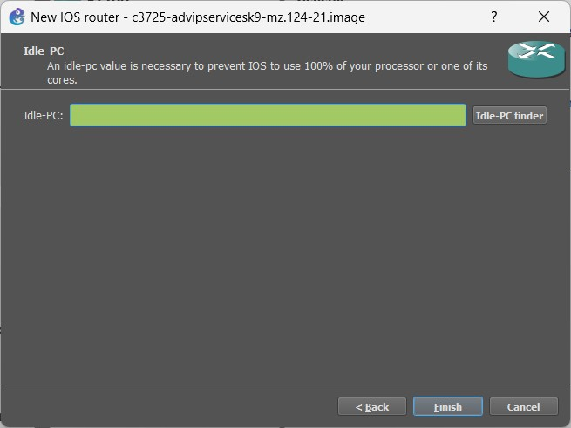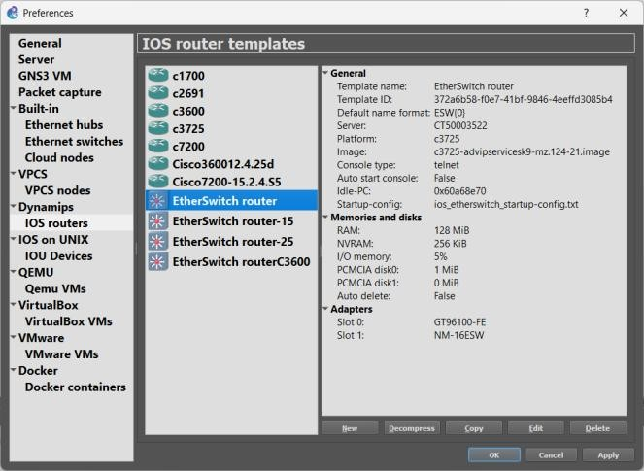

The definition of the “Idle-PC” value will allow the host machine to assign the correct amount of resources to the virtual devices. You must repeat this procedures every time your PC CPU reaches values higher than 90%. Check the CPU utilization with the “Task Manager” in Windows, top command in Linux and “monitor” in MacOS.

To define the “Idle-PC” value:

* Click "Idle-PC finder" during template setup, OR
* Add router to project, start it (should be the only one ON), open console (wait for prompt), left click the device and choose option "Auto Idle-PC", OR
* Add router to project, start it (should be the only one ON), open console (wait for prompt), left click the device and choose option "Idle-PC", choose one value (prefer the ones marked with *) and verify the CPU utilization. If any "dynamips" process is using more than 5%-10% CPU choose another value.

This must be done for each router template, NOT each router! Each template will have a different “Idle-PC” value. All routers from the same template will share the same value.

Note 1: All devices from the same template must be equal in terms of virtual hardware.

Note 2: After changing any device hardware characteristic or adding/removing network modules, the “Idle-PC” value must be changed in the template. If necessary, create a new template with different characteristics/modules.

Note: At this phase your GNS3 installation should have (at least):

* A Cisco c7200;
* An “EtherSwitch” (Layer 3 switch) based on a router c3725 with a 16 port switch module;
* An “Ethernet Switch”, consumes less memory and CPU, but does not have an IP address;

## 2. Part B – Open/create a project

### 2.1. Run GNS3 and define a simple network

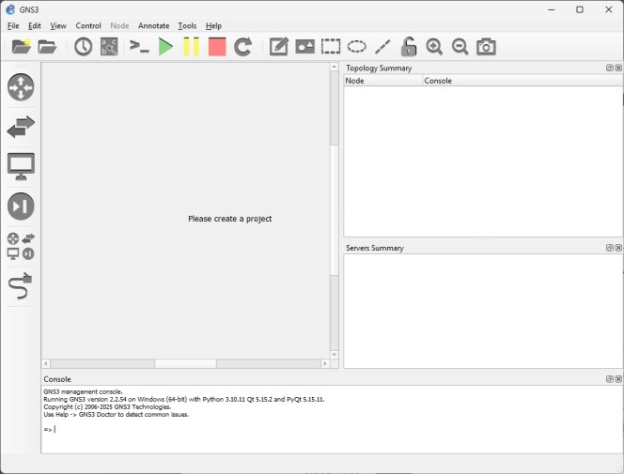

Wait for the local server to be up and running



Create a new project and a storage location. The complete path ad the filename MUST NOT HAVE special characters (ç, ~, ´, `, ^, etc)

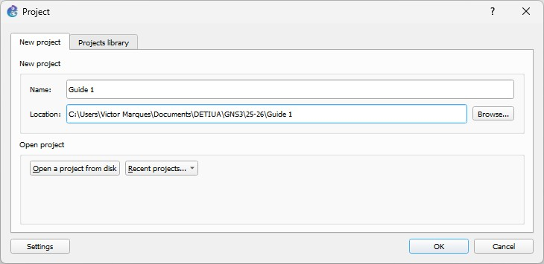

Build the following network

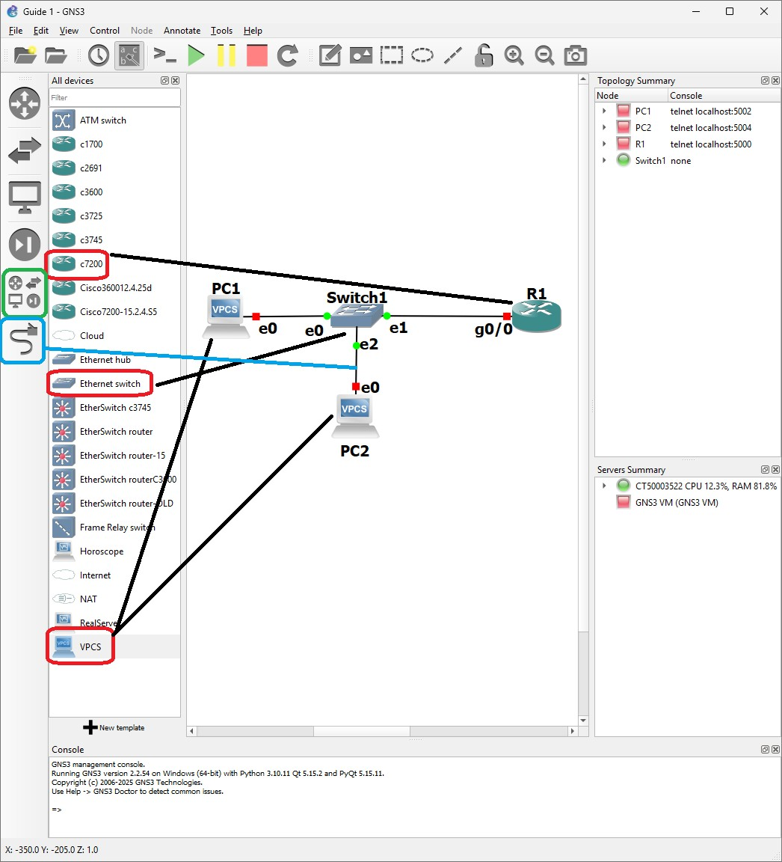

Click on “play” to start all the elements. Click on the “a, b, c” icon to see the interfaces IDs on the devices.



Rigth click on the router and on the VPCs to access the console:

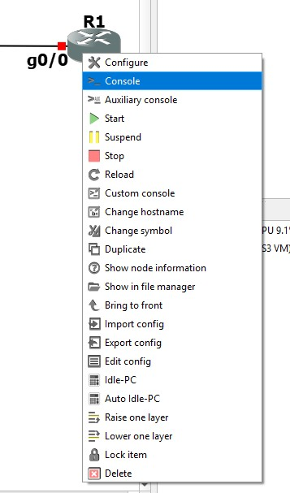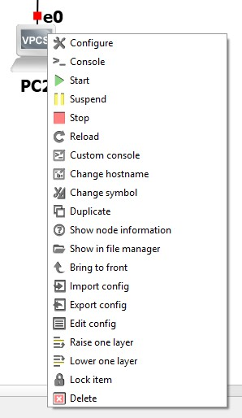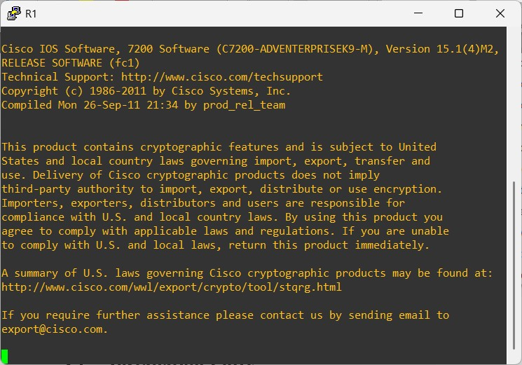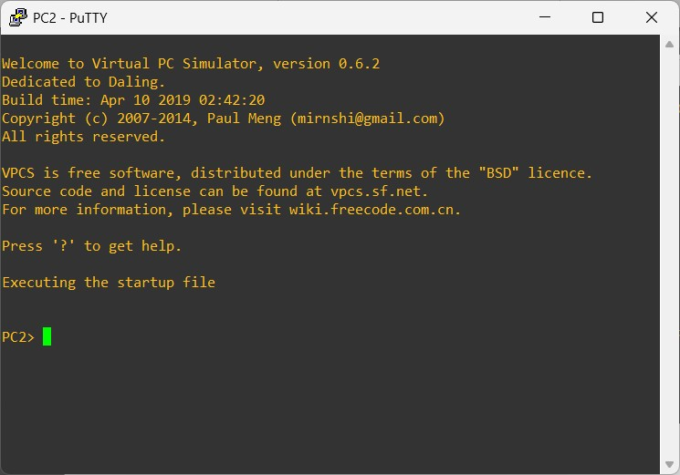

Wait for the router to load its operating system and then click return a few times:

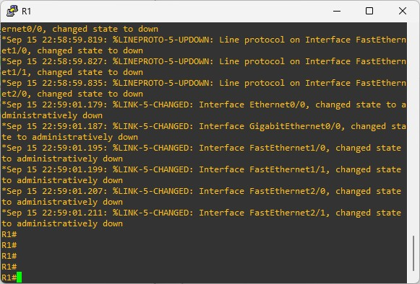

You are now ready to configure your network.

## 3. Part C – Configure the network inside GNS3

(please check the Guide-Commands and the Cisco-Commands PDFs for extra information) a) Cisco:

### Router# configure terminal // conf t

Router(config)# **interface GigabitEthernet0/0** // Enter interface configuration mode

Router(config-if)# **ip address 192.168.1.1 255.255.255.0** // Assign IPv4 address

Router(config-if)# **no shutdown** // Enable the interface

Router(config-if)# **exit** // ^Z

Router# show run // View the current router configuration

Router# write // save the configuration

b) **Configuration of the VPCs (configuring and IP address):**

On the VPC1 Console: PC1> ip 192.168.1.100/24

On the VPC2 Console: PC2> ip 192.168.1.200/24

PC1/PC2> save (to save the configuration)

### c) Test Connectivity from the VPC to the router: PC1> ping 192.168.1.1 -T 1

1. **Test Connectivity from the router to the VPCs:**

Router# ping 192.168.1.100

Router# ping 192.168.1.200

1. **Test Connectivity between VPCs:**

On the VPC1 Console: PC1> ping 192.168.1.200 -T 1

On the VPC2 Console: PC2> ping 192.168.1.100 -T 1

### f) Run Wireshark on the Router Link

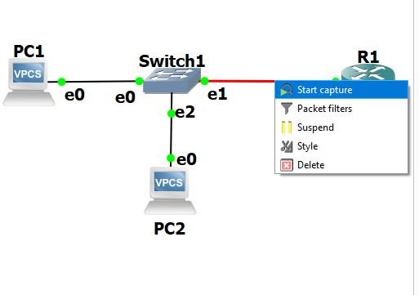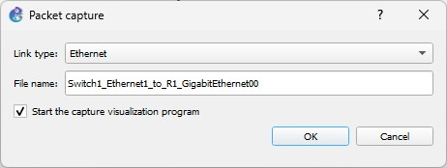

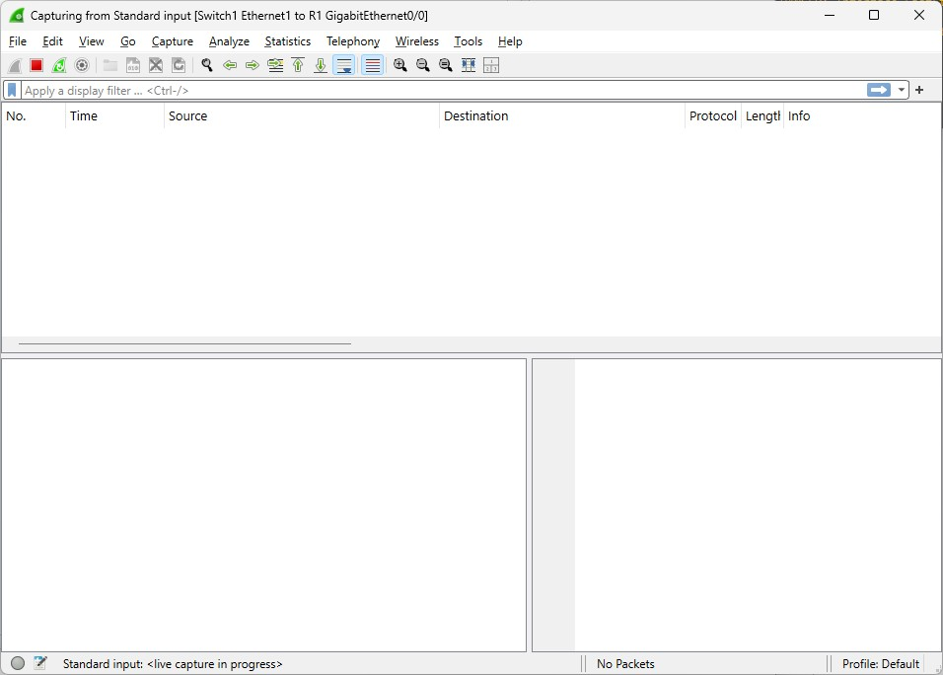

## 4. Part D - Base “Internet” Experiments

### 4.1. Objectives

* Verify the network configuration of a PC
* Name translation to IP addresses and vice-versa
* Connectivity tests
* Discovery of the path between two network machines
* Geo-location and discovery of the entity and responsible for the network machines

### 4.2. Verify the network configuration of a PC

a) Open a command window and execute the command *ipconfig* and register: (i) how many network interfaces (Linux: *ip link;* MAC: *ifconfig*) and (ii) the IP address and the *default gateway* of each interface (Linux: *ip addr* e *ip route;* MAC: *netstat -r*).

|  |
| --- |
| b) Repeat the command *ipconfi*g with the option */all* and register: (i) the name of the machine (Linux:  *cat /etc/hostname*), (ii) the physical address of each interface (Linux: *ip addr*) and (iii) the DNS servers IP addresses (Linux: *cat /etc/resolv.conf*). |

### 4.3. Name translation to IP addresses and vice-versa

1. In a command window, using the command *nslookup* (same in Linux), determine the IP addresses associated to each of the following names:

|  |  |
| --- | --- |
| **Name** | **IP Address(es)** |
| [www.ua.pt](http://www.ua.pt/) | 193.136.173.58 |
| ua.pt |  |
| [www.tvi.iol.pt](http://www.tvi.iol.pt/) | 193.126.240.138 |
| [www.sapo.pt](http://www.sapo.pt/) | 213.13.145.114 |
| [www.tsf.pt](http://www.tsf.pt/) | 104.26.10.188  104.26.11.188  172.67.70.150 |
| [www.antena3.pt](http://www.antena3.pt/) | 94.46.160.176 |
| [www.rtp.pt](http://www.rtp.pt/) | 146.75.90.192 |
| [www.publico.pt](http://www.publico.pt/) | 108.157.98.54  108.157.98.35  108.157.98.97  108.157.98.113 |
| [www.google.com](http://www.google.com/) | 142.250.178.164 |
| [www.google.pt](http://www.google.pt/) | 216.58.215.163 |
| [www.google.es](http://www.google.es/) | 172.217.17.3 |
| [www.google.fr](http://www.google.fr/) | 142.250.200.99 |

nslookup [{address_to_find}]

1. Using the command *nslookup* determine the name associated to the following IP addresses:

|  |  |
| --- | --- |
| **IP Address** | **Name** |
| 193.136.173.58 | lvs-ng.ua.pt |
| 193.137.55.13 | www.up.pt |
| 157.240.212.35 | edge-star-mini-shv-01-lis1.facebook.com |
| 31.13.66.174 | instagram-p42-shv-01-iad3.fbcdn.net |

1. Open the browser and access to each of the following URLs:

|  |
| --- |
| **Addresses** |
| 193.137.55.13 |
| 157.240.212.35 |

### 4.4. Connectivity tests

a) In a command window execute the command *ping* (same in Linux) to the following addresses, and register the average round trip time. What can you conclude about the relation between the round trip time and the geographical distance? Note: If pings do not work, connect through the WiFi network in the lab.

|  |  |  |
| --- | --- | --- |
| **Addresses** | **Machine location** | **Average round trip time** |
| [www.ua.pt](http://www.ua.pt/) | Aveiro, Portugal (0Km) | 31ms |
| www.up.pt | Porto, Portugal (~60Km) | 17ms |
| [www.fc.ul.pt](http://www.fc.ul.pt/) | Lisboa, Portugal (~220Km) |  |
| [www.utad.pt](http://www.utad.pt/) | Vila Real, Portugal  (~160Km) |  |
| [www.uevora.pt](http://www.uevora.pt/) | Évora, Portugal (~250Km) | Timed out |
| [www.uam.es](http://www.uam.es/) | Madrid, Espanha (~420Km) | Timed out |
| www.univ-paris8.fr | Paris, França (~1260Km) |  |
| web.mit.edu | EUA (~5100Km) | 46ms |
| [www.zju.edu.cn](http://www.zju.edu.cn/) | China (~7200Km) | 69ms |
| www.unisa.ac.za | África do Sul (~8750Km) | Timed out |
| www.adelaide.edu.au | Austrália (~17100Km) | Timed out |
| www.tanzaniatourism.go.tz | Tanzânia (~3100Km) | Timed out |

### 4.5. Discovery of the path between two network machines

a) In a command window execute the command *tracert* (Linux: *traceroute*) to the following addresses, and register the number of network machines between the origin and destination, and the address of the antepenultimate machine in the path. Repeat using the option *–d* of the *tracert* command.

|  |  |  |  |
| --- | --- | --- | --- |
| **Addresses** | **Machine location** | **Number of machines** | **IP address of the**  **antepenultimate**  **machine in the path** |
| [www.ua.pt](http://www.ua.pt/) | Aveiro, Portugal (0Km) | 11 | 193.136.4.27 |
| www.up.pt | Porto, Portugal (~60Km) | 8 | 213.30.93.107 |
| www.fc.ul.pt | Lisboa, Portugal (~220Km) |  |  |
| www.utad.pt | Vila Real, Portugal (~160Km) |  |  |
| www.uevora.pt | Évora, Portugal (~250Km) |  |  |
| [www.uam.es](http://www.uam.es/) | Madrid, Espanha (~420Km) |  |  |
| www.univ-paris8.fr | Paris, França (~1260Km) |  |  |
| web.mit.edu | EUA (~5100Km) |  |  |
| www.zju.edu.cn | China (~7200Km) |  |  |
| www.unisa.ac.za | África do Sul (~8750Km) |  |  |
| www.adelaide.edu.au | Austrália (~17100Km) |  |  |
| jornalnopintcha.gw | Guiné Bissau (~3100Km) |  |  |

### 4.6. Discovery of the entity and responsible for the network machines

a) Using the service *whois,* through the web page https://who.is/ (or https://ping.eu/ns-whois/), determine (if possible), for each of the *trace routes* in 4.1: the entity responsible by the **antepenultimate** machine of each path and the location of that entity.

|  |  |  |
| --- | --- | --- |
| **IP address** | **Responsible entity** | **Location of the entity** |
|  |  |  |
|  |  |  |
|  |  |  |
|  |  |  |
|  |  |  |
|  |  |  |
|  |  |  |
|  |  |  |
|  |  |  |
|  |  |  |
|  |  |  |
|  |  |  |

### 4.7. Geo-location of IP addresses

a) Using the geo-location service, through the web page [http://www.hostip.info,](http://www.hostip.info/) determine for each of the *trace routes* in 5, the geographic location of the **antepenultimate** machine of each path. Note: this service is not precise.

|  |  |  |  |  |
| --- | --- | --- | --- | --- |
| **Addresses** |  | **Location** | |  |
| **Country** |  |  | **City** |
|  |  |  |  |  |
|  |  |  |  |  |
|  |  |  |  |  |
|  |  |  |  |  |
|  |  |  |  |  |
|  |  | |  | | |
|  |  | |  | | |
|  |  | |  | | |
|  |  | |  | | |
|  |  | |  | | |
|  |  | |  | | |
|  |  | |  | | |

## 5. Annex A

### 5.1. Installation Putty

Download and install Putty: <https://www.putty.org/>

In order to access the routers and switches console ports you will need to use a USB serial adapter.

Depending on the adapter you are using, you will need to find it on the device manager, under “Ports” (COM & LPT) to identify the right COM port:

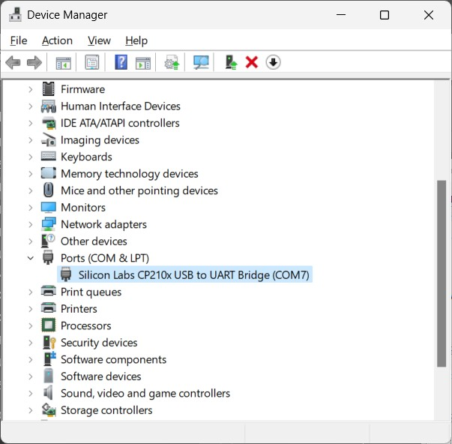

To access the routers and switches console, you need to configure it as shown below:

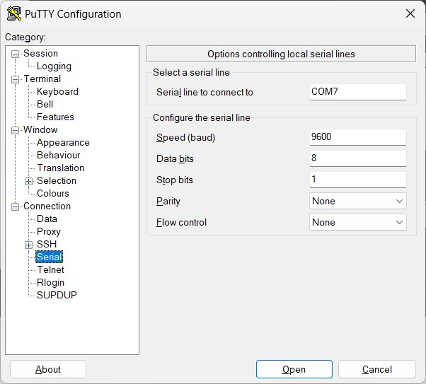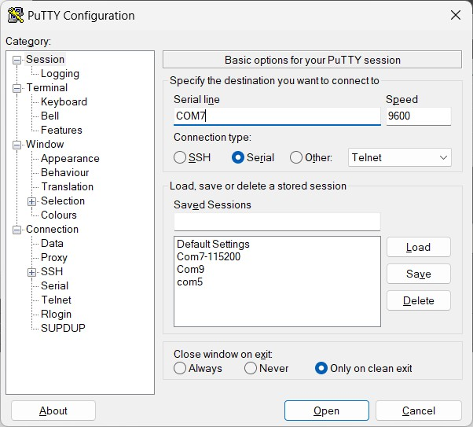

**For Linux**, use **picocom**: sudo apt install picocom sudo picocom -b 9600 /dev/ttyUSB0

(check under /dev which is the ttyUSB you have)

Putty is also available for Linux, if you desire:

sudo apt update

sudo apt install putty

**For macOS:**

PuTTY is not natively available for macOS, but you can use alternatives like Terminal or iTerm2 for SSH connections.

If you prefer PuTTY specifically, you can use a tool like Homebrew to install it.

Open a terminal window.

Install PuTTY (Alternative using Homebrew):

If you haven't installed Homebrew yet, you can do so by running the following command:

/bin/bash -c "$(curl -fsSL https://raw.githubusercontent.com/Homebrew/install/HEAD/install.sh)"

Once Homebrew is installed, you can install PuTTY using the following command: brew install putty

The same cable/adapter may be used to access the routers and the switches and you may switch from one to the other without stopping putty.

### 5.2. Installation of Wireshark

Visit the official Wireshark website: https://www.wireshark.org/

Click on the "Download" link and select the Windows version.

Choose either the 32-bit or 64-bit installer, depending on your system architecture.

Follow the on-screen instructions to download the installer.

You may be prompted to install additional components like WinPcap or Npcap; follow the prompts if necessary.

You may need administrative privileges to capture network traffic, so ensure you run Wireshark as an administrator if needed.

Linux:

Open a terminal window.

Use your distribution's package manager to install Wireshark. For Debian/Ubuntu-based systems, you can use: sudo apt update sudo apt install wireshark

During the installation process, you may be prompted to add your user to the 'wireshark' group to allow capturing packets without root privileges. Follow the on-screen instructions to do so if desired.

After installation, you may need to configure Wireshark to allow non-root users to capture packets. Run the following command in the terminal:

sudo dpkg-reconfigure wireshark-common

Select "Yes" to allow non-superusers to capture packets and follow any additional prompts.

Once installed and configured, you can launch Wireshark from the applications menu or by typing 'wireshark' in the terminal.

macOS:

Download Wireshark: https://www.wireshark.org/ Download the macOS version of Wireshark.

You may need to install XQuartz if you haven't already, as Wireshark for macOS requires it to run.

You can download XQuartz from https://www.xquartz.org/ and follow the installation instructions.